Machine Learning-Assisted Exploration of Thermally Conductive Polymers: A Comprehensive Report
Created by Harsh Hotala and Vivek Kumar
Executive Summary
This comprehensive report examines the pioneering research on machine learning-assisted exploration of thermally conductive polymers using high-throughput molecular dynamics simulations. The study addresses a critical challenge in materials science: the scarcity of amorphous polymers with high thermal conductivity (TC) and the lack of comprehensive databases to guide their discovery. By combining advanced computational techniques with machine learning algorithms, researchers have successfully identified 121 polymers with thermal conductivity exceeding 0.300 W/m-K, including 34 polymers with TC above 0.400 W/m-K—a remarkable achievement in the field of polymer informatics[1].
1. Introduction: The Thermal Conductivity Challenge in Polymers
1.1 Importance of Thermally Conductive Polymers
Bulk amorphous polymers have long been characterized as thermal insulators, yet they remain ubiquitous in applications where heat transfer is critical, including thermal interface materials, heat exchangers, and thermal energy storage mediums[1]. Traditional approaches to enhancing polymer thermal conductivity have focused on compositing thermally conductive fillers (metals, ceramics, carbon nanotubes) with amorphous polymer matrices. However, substantial research has demonstrated that the polymer matrix's intrinsic thermal conductivity has a major impact on composite TC, with higher matrix TC leading to greater enhancement in overall composite performance[1].
1.2 The Data Gap Problem
Despite progress in understanding thermal transport physics in polymers, relatively limited information exists about which types of amorphous polymers are better at conducting heat, and experimentally screening large numbers of polymers remains very challenging[1]. The largest existing polymer database, PoLyInfo, contains very limited numbers of pure polymers with TC values, and many of these records suffer from significant noise due to different polymer synthesis, processing, and thermal conductivity measurement methods employed across various studies[1]. This gap creates a critical need to establish structure-thermal conductivity relations that can quickly screen numerous polymers to identify promising candidates for experimental exploration.
1.3 Previous Approaches and Limitations
Recently, data-driven approaches leveraging machine learning have been developed to establish structure-property relations for various materials. However, such efforts for polymer thermal conductivity have been very limited. Wu et al. leveraged transfer learning to establish a structure-TC surrogate model with predictive accuracy of R² = 0.732 based on only 28 experimental TC data points from PoLyInfo[1]. While their designed polymer achieved the notable TC of 0.410 W/m-K for amorphous polymers, the transfer learning technique—though helpful in addressing small dataset issues—still suffered from limited data availability. This study addresses these limitations by leveraging high-throughput molecular dynamics simulations to generate TC data for quantifying structure-TC relations across a large polymer space.
2. Methodology: High-Throughput Molecular Dynamics Pipeline
2.1 Computational Framework Overview
The research employs a sophisticated, automated computational pipeline that generates thermal conductivity data through high-throughput molecular dynamics simulations. The general procedure consists of two main steps: amorphous structure optimization and non-equilibrium molecular dynamics (NEMD) thermal conductivity calculation, as depicted in detailed workflow diagrams[1].
2.2 Amorphous Polymer Structure Generation
The initial phase of the methodology involves generating amorphous polymer structures from molecular representations:
Data Collection and Representation: The structures of 12,777 homopolymers were collected from the PoLyInfo database and stored in monomer format, represented using SMILES (Simplified Molecular Input Line Entry System) strings[1]. A Python pipeline based on PYSIMM was developed to automatically generate amorphous polymer structures taking SMILES strings of monomers as input.
Polymer Chain Construction: The pipeline first polymerizes monomers into polymer chains, controlling the number of atoms per chain to approximately 600 for all simulated polymers. This results in polymer chain lengths ranging from approximately 6 to 40 nm, with variations due to polymer branching structures[1]. Previous studies have demonstrated that thermal conductivity does not change significantly after chain size exceeds 600 atoms, validating this choice.
Forcefield Parameter Assignment: The General AMBER Force Field 2 (GAFF2) parameters were assigned to polymers, automatically generating input scripts for molecular dynamics simulations using the large-scale atomic-molecular massively parallel simulator (LAMMPS)[1]. Polymers with missing GAFF2 forcefield parameters were excluded from analysis, which represents a practical limitation in chemical space coverage.
2.3 Polymer Structure Optimization Process
Initialization Phase: The polymer system was subjected to a carefully designed initialization process involving multiple simulation steps. The system was first simulated with electrostatic interactions turned off and a Lennard-Jones cutoff of 0.300 nm[1]. The polymer structure underwent NPT ensemble simulation at 100 K for 2 picoseconds, followed by heating to 1000 K over 1 nanosecond, then NPT simulation for 50 picoseconds at 0.1 atm and 1000 K. Finally, the system was simulated under NPT at 1000 K for 1 nanosecond with pressure allowed to increase to 500 atm, using SHAKE constraints to enable larger time steps[1].
Annealing and Relaxation Stages: After initialization, the polymer system underwent annealing with electrostatic interactions enabled using the PPPM (Particle-Particle-Particle-Mesh) Ewald sum method, with a Lennard-Jones cutoff of 0.800 nm[1]. The system was first simulated in NPT ensemble at 1 atm and 1000 K for 2 picoseconds. Subsequently, the system was cooled from 1000 K to 300 K at a cooling rate of 140 K/nanosecond in NPT ensemble at 1 atm, followed by additional NPT simulation at 300 K and 1 atm for 8 nanoseconds to achieve the final amorphous state[1]. These procedures ensure reliable achievement of amorphous polymer states rather than attempting to mimic experimental annealing processes.
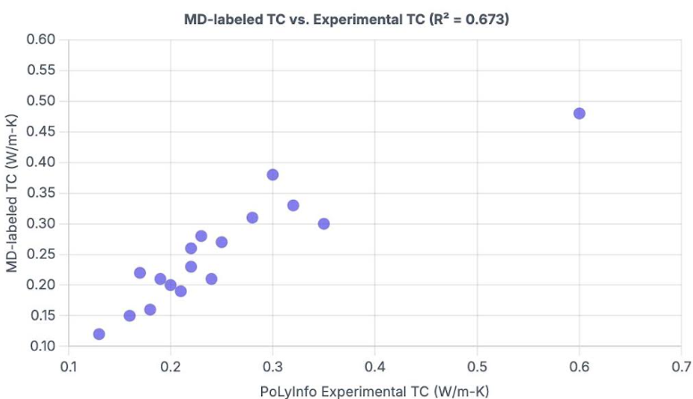
2.4 Thermal Conductivity Calculation via NEMD
Sample Preparation: Each relaxed amorphous polymer structure in a cubic box was duplicated in three copies to form a cuboid with dimensions approximately 9.900 × 3.300 × 3.300 nm³[1]. The dimensions varied slightly based on density differences across different polymers.
Non-Equilibrium Molecular Dynamics Simulation: The extended system was used to calculate thermal conductivity using NEMD simulations. The system ran in an NVE (constant number of atoms, volume, and energy) ensemble for 5 nanoseconds with a time step of 0.25 femtoseconds[1]. Heat source (320 K) and sink (280 K) were imposed using Langevin thermostats near the system ends, with thermostat regions 0.500 nm thick. Fixed regions at each end prevent system drifting and heat flow across periodic boundaries.
Thermal Conductivity Determination: The recorded heat flux (calculated from heat addition/subtraction in Langevin heat baths) and temperature profile were averaged over the last 4 nanoseconds of the production run[1]. Thermal conductivity was calculated using Fourier's law: κ = J/(∇T), where κ is thermal conductivity, J is heat flux, and ∇T is the temperature gradient obtained from linear fitting of the temperature profile. Standard deviations of TC values were calculated by dividing production run data into 8 time periods with each producing a TC value[1].
3. Validation and Benchmarking
3.1 Comparison with Experimental Data
The validity of the MD simulation pipeline was rigorously assessed through systematic benchmarking against existing experimental thermal conductivity measurements from PoLyInfo. For 29 polymers with available experimental TC data, the MD-calculated values showed reasonable agreement, with coefficient of determination (R²) of 0.673 overall[1]. Importantly, when considering only polymers with three or more experimental data points in PoLyInfo (reducing noise from heterogeneous measurement conditions), the agreement improved to R² = 0.742[1].
3.2 Sources of Experimental Data Variability
Considerable noise exists in experimental TC values due to differences in sample preparation, polymer processing, and measurement techniques. The study provides detailed examples of data cleaning procedures. For polymer P130085 (polyimide), reported values ranged from 0.11 to 0.21 W/m-K; careful analysis revealed that thin-film measurements exhibited significant anisotropy (factor of 4-8) requiring correction for cross-plane vs. in-plane thermal conductivity[1]. Similarly, for polyaniline (P460064), seven reported neat polymer TC values ranged from 0.16 to 0.35 W/m-K, reflecting variations in fabrication methods and measurement techniques. Despite these discrepancies, the MD-calculated TC of 0.479 ± 0.041 W/m-K showed reasonable agreement with averaged experimental data of 0.59 ± 0.41 W/m-K[1].
3.3 Sensitivity Analysis: Parameter Variations
Annealing Temperature Effects: To assess simulation robustness, 15 polymers with diverse MD-labeled TC values (0.172-0.394 W/m-K) were re-calculated using different annealing temperatures of 600, 1500, and 2000 K (compared to the original 1000 K)[1]. Results shown as parity plots revealed positive overall correlation between TC data from different annealing temperatures, though variations up to 0.040 W/m-K occurred, generally larger for higher-TC polymers[1]. Importantly, no systematic change of TC with respect to annealing temperature was observed.
Cooling Rate Variations: Six polymers with diverse TC were re-calculated using different annealing rates of 80, 100, 120, and 150 K/ns (compared to original 140 K/ns), with annealing temperature fixed at 1500 K[1]. Results showed that different annealing rates led to only minor TC variations with no systematic trend observed. Critically, polymers predicted to have TC > 0.300 W/m-K from original calculations remained above this threshold in new test conditions[1].
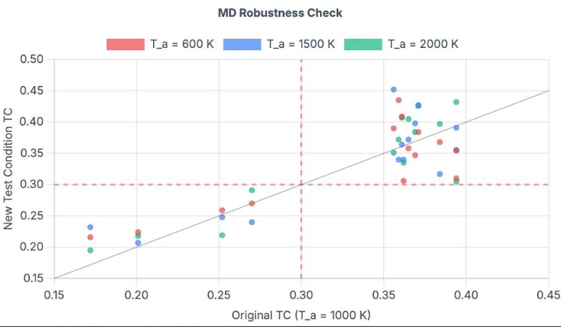
High-Temperature Relaxation Time Effects: Four polymers (with two near 0.20 W/m-K and two exceeding 0.35 W/m-K) were simulated with high-temperature relaxation times of 3 and 30 nanoseconds (compared to original 0 ns)[1]. Results showed that radius of gyration trends and final values were very similar, with resulting TC values mostly within error bars of previous calculations and no systematic trend observed[1].
Morphology Randomness as Primary Uncertainty Source: Analysis revealed that variation in density was small across different simulation conditions and did not correspond to TC variation, suggesting that randomness in polymer morphology was the primary source of TC uncertainty[1]. This observation was confirmed by comparison of within-simulation TC uncertainty (7-10%, more consistent) versus inter-ensemble uncertainty (7-20%, more spread), with larger disparity for high-TC polymers. This pattern is consistent with rigid polymers typically having larger TC while being more difficult to relax and thus showing greater structural diversity in simulations[1].
4. Machine Learning Architecture and Training
4.1 Random Forest Regression Model
The study employed a Random Forest (RF) regression model to learn the structure-thermal conductivity relation. Random forests were selected for their robustness and ease of training compared to neural networks when working with small to medium datasets[1].
Polymer Representation Using Mol2Vec Embeddings: Each polymer was represented using a polymer embedding—a 300-dimensional continuous-valued vector derived through mol2vec training on over 1,008,576 polymer structures from the combined PoLyInfo and PI1M databases[1]. The mol2vec technique decomposes monomers into sequences of substructures, using the center substructure as input to a single-hidden-layer neural network to predict surrounding substructures. The polymer embedding is derived from the weights of the hidden layer after training[1].
Model Training and Validation: The RF model was trained using 10-fold cross-validation with the number of trees optimized to 1,500 through grid search hyperparameter optimization[1]. On validation sets, the model achieved prediction accuracy of R² = 0.789 ± 0.030, demonstrating strong predictive capability for thermal conductivity within the simulated range[1].
Initial Dataset Characteristics: The initial training dataset of 365 randomly selected polymers showed significant class imbalance, with 324 polymers (89%) having MD-labeled TC below 0.300 W/m-K and only 41 above this threshold[1]. This distribution reflects the scarcity of high-thermal-conductivity polymers in the broader chemical space.
4.2 Machine Learning-Guided Screening Strategy
Database Screening: Rather than continuing to generate data for randomly selected polymers, the trained RF model was deployed to predict TC for all 12,777 polymers in the PoLyInfo database. This identified 880 polymers with RF-predicted TC greater than 0.300 W/m-K (the critical threshold established through sensitivity analysis)[1]. From these candidates, 89 polymers were randomly selected for validation through MD simulation.
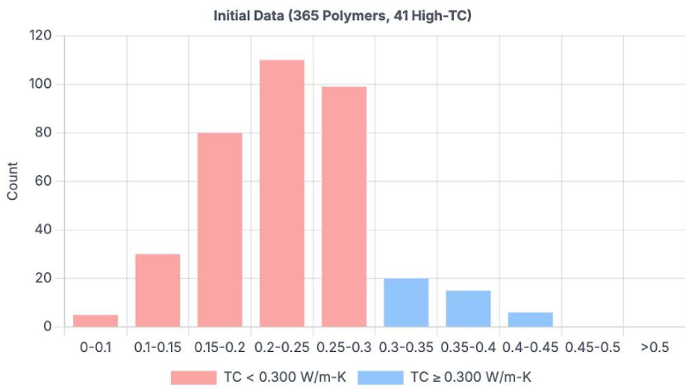
Dramatic Improvement in Discovery Efficiency: Among the 89 ML-guided candidates, 80 polymers (89.9%) had MD-calculated TC above 0.300 W/m-K, compared to 41 out of 365 (11%) in the original random dataset[1]. This represents an approximately 9-fold increase in discovery efficiency—a transformative improvement in screening productivity.
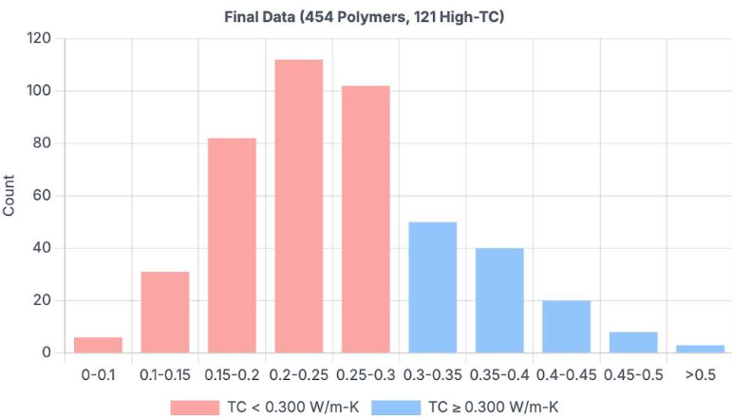
Expanded High-TC Database: The combined dataset of 454 polymers (365 original + 89 newly screened) now includes 121 polymers with TC exceeding 0.300 W/m-K (26.7% of total), compared to the initial 11.2%[1].
4.3 Bayesian Neural Network for Uncertainty Quantification
Recognizing inherent uncertainties in both MD simulations and ML predictions, the study implemented a Bayesian Neural Network (BNN) to quantify prediction uncertainty[1].
Uncertainty Classification: Prediction uncertainty comprises two components: epistemic uncertainty (arising from incomplete information, model imperfection, or data sparsity—reducible with more data) and aleatoric uncertainty (due to inherent stochasticity of physical processes—irreducible)[1]. In this study, aleatoric uncertainty reflects the inherent uncertainty of MD results for a given polymer.
BNN Architecture and Training: The BNN employs a multilayer perceptron with three layers and 100 hidden neurons per layer[1]. Rather than using traditional variational inference algorithms (which can be difficult to converge), the study adopted the Stochastic Weight Averaging-Gaussian (SWAG) algorithm—a scalable, SGD trajectory-based approach that effectively represents the loss landscape[1]. During pre-training, learning rates were gradually reduced from 1 × 10⁻² to 1 × 10⁻³, with ensemble statistics collected along SGD trajectories. Inference was performed in a 10-dimensional subspace derived from PCA decomposition of SGD trajectories[1].
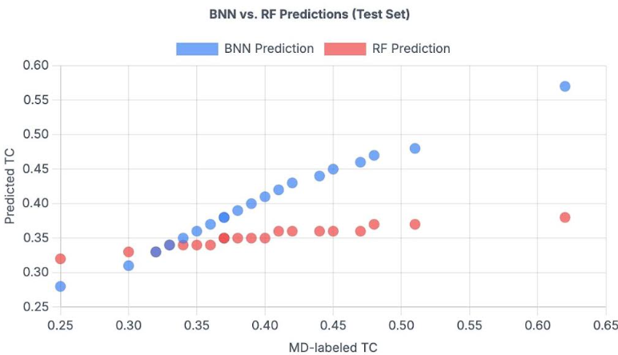
Mapping Mean-Variance Relationships: To account for scenarios where test data standard deviation information is unavailable, the study used Bayesian Linear Regression (BLR) to capture the positive relationship between TC mean and standard deviation observed in training data[1]. This relationship was assumed to hold for test datasets, enabling reasonable estimates of aleatoric uncertainty for test polymers.
BNN Performance Characteristics: Comparison of BNN and RF model predictions revealed that RF predictions were concentrated in a narrow range (0.32-0.37 W/m-K), while BNN predictions covered a wider range (0.31-0.57 W/m-K) closer to actual MD-labeled data (0.25-0.53 W/m-K)[1]. Among 89 test polymers, 94% of MD labels fell within the BNN-predicted uncertainty range, with only 5 outliers[1]. This demonstrates that the BNN provides superior mean prediction accuracy while effectively capturing prediction uncertainty.
5. Results: Discovery of High-Thermal-Conductivity Polymers
5.1 Distribution of Thermal Conductivity Values
The initial dataset of 365 randomly selected polymers showed thermal conductivity values ranging from 0.035 to 0.395 W/m-K, with the vast majority (324 out of 365, or 89%) below the 0.300 W/m-K threshold[1]. After ML-guided screening and additional MD simulations, the combined dataset of 454 polymers included 121 with TC exceeding 0.300 W/m-K and 34 with TC above 0.400 W/m-K—an unprecedented discovery rate for the field[1].

5.2 Chemical Classification of High-TC Polymers
Polymer Class | Number with TC > 0.400 W/m-K
Polyamides | 10
Polysulfides | 12
Polyvinyls | 2
Polyoxides | 4
Polyimines | 1
Polyolefins | 1
Polyesters | 1
Other | 3
Total | 34

Table 1: Distribution of 34 highest TC polymers by chemical class
Polyamides and Polysulfides as Leading Classes: Among the 34 highest thermal conductivity polymers (TC > 0.400 W/m-K), 22 belong to polyamides (10 polymers) and polysulfides (12 polymers)[1]. This concentration is particularly significant because it aligns with prior research predictions and validates theoretical understanding of rigid-chain polymers. Notable polyamides include poly[(dodecane-1,12-diamine)-alt-(dodecanedioic acid)] with TC of 0.515 W/m-K[1].
Representative High-TC Polymers: Key discoveries include:
- Poly[(octadecane-1,18-diamine)-alt-(dodecanedioic acid)]: 0.515 W/m-K
- Poly(dodecamethylene oxide) [Polyoxide]: 0.506 W/m-K
- Poly(3-tetradecylthiophene) [Polysulfide]: 0.468 W/m-K
- Poly(tetradecamethylene sulfide) [Polysulfide]: 0.442 W/m-K[1]
Broader Chemical Diversity: Beyond the dominant polyamides and polysulfides, the remaining 12 high-TC polymers span polyvinyls, polyoxides, polyimines, polyolefins, and polyesters, demonstrating that the ML screening approach identifies promising candidates across diverse chemical scaffolds[1].
5.3 Structural Variation and Robustness Testing
To account for uncertainty in MD calculations due to morphology randomness, the 34 highest-TC polymers were re-simulated with different initial structures[1]. Results showed that 22 out of 34 maintained TC above 0.400 W/m-K across different simulations, and all except one maintained TC above 0.360 W/m-K[1]. This high persistence rate (94%) demonstrates the robustness of the high-TC predictions despite inherent simulation uncertainties.
6. Discussion: Implications and Future Directions
6.1 Paradigm Shift in Materials Discovery
This work exemplifies a transformative paradigm in materials discovery, combining molecular simulation with machine learning to automate polymer identification. The leap from 11% hit rate (random search) to 89.9% hit rate (ML-guided search) demonstrates the power of data-driven approaches in materials screening[1].
6.2 The Iterative ML-MD Approach
The study reveals an effective iterative strategy: training ML models on simulation data, using predictions to guide new simulations, validating predictions through simulation, and progressively expanding the dataset. While current ML models are limited by the initial scarcity of high-conductivity training data, this iterative approach can gradually extend the upper boundary of discoverable polymer thermal conductivity[1].
6.3 Opportunities for Further Enhancement
Chain Orientation Effects: Recent studies report TC values exceeding 0.9 W/m-K in chain-oriented polymers, though such samples retain overall amorphous structure[1]. Future work should explicitly incorporate orientation factors into the MD simulation pipeline, as chain alignment in amorphous polymers substantially increases thermal conductivity.
Expanded Chemical Space: Extending the approach to include semicrystalline polymers, blends, and composite materials could further expand the reach of the discovery platform[1].
Multi-Property Optimization: While this study focuses on thermal conductivity, the platform could be extended to simultaneously optimize multiple properties (mechanical strength, processing temperature, cost) for practical application development[1].
6.4 Experimental Validation Priorities
The identification of 121 new high-TC polymer candidates provides a rich dataset for experimental validation. Priority should be given to polyamides and polysulfides given their strong predictive performance and potential for near-term experimental synthesis and characterization[1]. Systematic experimental confirmation will refine the structure-property relationships and potentially reveal additional high-TC materials not captured by current simulations.
7. Conclusions and Impact
7.1 Major Achievements
This research demonstrates a scalable, automated framework for polymer materials discovery that integrates high-throughput molecular dynamics with robust machine learning algorithms. The study successfully:
- Generated a large, clean dataset of 454 polymer thermal conductivity values through automated MD simulations
- Developed accurate ML surrogate models (RF and BNN) quantifying structure-property relationships
- Achieved 9-fold improvement in discovery efficiency through ML-guided screening
- Identified 121 polymers with high TC (> 0.300 W/m-K) and 34 with exceptional TC (> 0.400 W/m-K)
- Established rigorous uncertainty quantification methods for both simulation and ML predictions[1]
7.2 Broader Significance
The methodology and findings have far-reaching implications:
For Materials Science: The work demonstrates that informed computational screening can dramatically accelerate materials discovery, potentially serving as a blueprint for other material classes and properties[1].
For Polymer Engineering: The identification of polyamides and polysulfides as particularly promising thermal conductors provides immediate direction for experimental researchers pursuing high-performance thermal management applications[1].
For Materials Informatics: The iterative ML-MD framework shows how computational and data-driven methods can synergistically guide discovery, establishing a reproducible, scalable platform for automated materials design[1].
7.3 Data Availability and Reproducibility
The authors have committed to making raw and processed data publicly available through the PI1M database (https://github.com/vivekweb3/MIML-Project_Database-for-Polymer-Informatics) upon or before manuscript publication, ensuring reproducibility and enabling further research[1]. This commitment to open science accelerates community contribution to thermal polymer discovery.
7.4 Future Vision
The convergence of materials simulation, machine learning, and experimental synthesis represents a new frontier in polymer science. Future efforts combining reinforcement learning, active learning strategies, and high-throughput experimental validation promise to further accelerate discovery cycles and unlock entirely new classes of polymeric materials optimized for thermal management, energy storage, and emerging technologies[1].
References
[1] Ma, R., et al. (2022). Machine learning-assisted exploration of thermally conductive polymers based on high-throughput molecular dynamics simulations. Materials Today Physics, 22, 100850.

